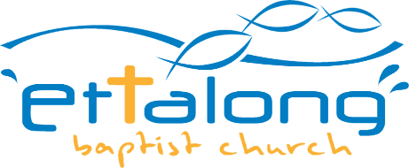

VENUE HIRER / USER LIABILITY FORM: INSURANCE COVER

It is essential that Facility Hirers / Users have their own Liability Insurance to protect themselves in the event of an accident.

However, for **private family functions** at the Church’s facilities, this can be covered under the Church’s existing Public Liability Policy by completing the details below.

The Public Liability Insurer has accepted that **“Private family functions”** – means birthdays, anniversaries, engagements, weddings and similar private events.

**Indemnity Limit : $20,000,000**

**Premium : Nil**

**Policy Wording : Available upon request from our office**

**Exclusions** **:**

1. Amusements. I.e. entertainers, other than singers and dance bands at a private family function.
2. Occasions held in business/company names, schools or commercial activities such as karate lessons, dancing classes, aerobics, bingo or discos, etc.

If Public Liability insurance cover is required for a “**private function**” please answer the following: Name of Hirer/User…………………………………………………………………….

Date of Function ……………………………………………………………….

Type of Function *(Anniversary ,21St Birthday Celebration, Wedding etc )*

No. of Invited Guests ………………………………………………………….

Signature of Hirer/User ……………………………...

Address …………………………………………

……………………………………………………

Date ……/………/……202_

Telephone …………….

**PLEASE NOTE:**

**PLEASE KEEP A COPY OF THIS FORM AS THIS WILL BE NEEDED IN THE EVENT OF A CLAIM.**